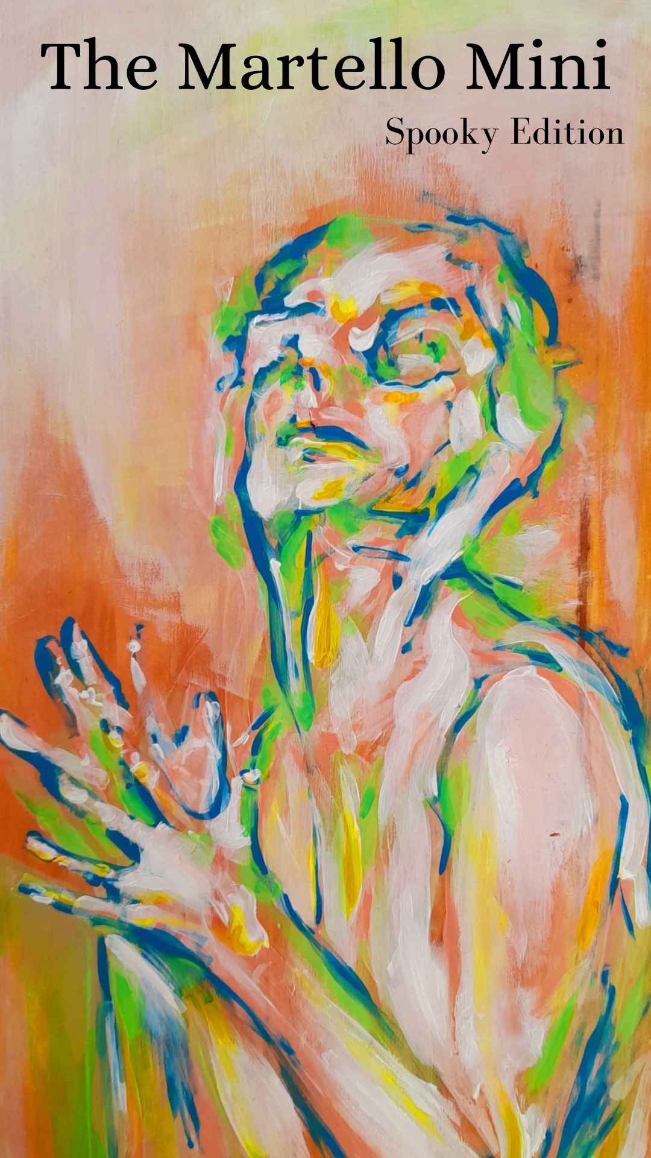
‘ghosts’, Summerilse Wilson.
The Martello
Edition 2:Mini
Editor’s Foreword

Friends,

It is our privilege to present to you this Martello Mini- the “fun-sized” version of everyone’s favourite literary magazine. It contains some incredible art from incredible talents: poetry, photographs, paintings, and short stories that will surely delight and amaze. Do be warned, however- this foreword is all that stands between you and 16 pages packed full of frights, chills, and haunts.

If you dare to continue on, you must do it right- wait ‘till it gets dark and windy, mull your wine, light your candles, stoke your fire, and make sure to keep a close eye on the shadows in the corner of the room.

Most important of all: please don’t forget to read out loud- the ghosts appreciate that sort of thing.

Please enjoy.
With love,

Úna and Jack

Contributors

Dan Wade

DW Evans

Alan O’Connor

Summerilse Wilson

Kim Welliver

Brian Keenan

Siobhán Mc Laughlin

Rebecca D’arcy

Emma McCoy

Úna Nolan

Docklands

The furculaic bridge keeps punter and pedestrian at bay.
Such subtly dystopian symmetry, such squarely-inked line
weight, chessboard pattern and glazing, claiming a stand
for progress, built to last for no more than three decades:
cut-glass monoliths catching sea-light, tall and clear!
As gealige agas as bearla*, the signs urge us not to smoke.

Like a signal to go underground, white plumes of smoke
pump from the Poolbeg Incinerator, clouding the bay,
roiling with traffic fumes, slithering contrail artery, clear
and cold as the rain’s marrow, dusk’s melting jawline,
or the moon’s whetted sneer. And now, two decades
into the millennium, where the latest tech tower stands,

a silicon cyst crisply sprouted like a pillar at the stands.
On the offshore breeze, there’s a worsening smell of smoke.
Here, see them cranes looming over Eden Quay
like crows pecking at soil? Their lifting hooks snag decades
in latticed beaks, outstretched and spiking the skyline.
Let me tell you, this is how they use an x-ray, clear

as glass, to microtarget our lives to their prophecy in ether
while, squawking like data updates, seagulls swarm inland
as pebbles melt into flame along Sandymount shoreline
where death takes its evening stroll after the last smoke
break, name-tagged with photo I.D. and passcode, the bay
of bloodhounds and cracked pavements to echo for decades,

right up where a black hole hovers, majesty of its void
whisking viruses of panic, melting steel and overturned cars
and sulphuric fireballs set to plummet from the sky
like algorithms that scan how, where and why your duty stands.
How long before the dead crawl from the waves to walk
past bus-stop and firewall, the circling dance of the moon

halted by blood bubbling the surf, bathing the fine line
between ash and dust in its jaundiced glow? Is this the last decade
to see the city as we know it before it goes up in smoke?
But, in fairness, if you actually remember the rust-smeared
girders propping up old fuel tanks and grey silos stand-
ing guard on the canal, you might be glad for the change,

too. New orders of living arise, from clouded to clear,
rebranded, reprogrammed in that sanitised image as the decade
draws to a close in claps of thunder over the cut-glass bay.
*In Irish and in English

-Dan Wade.
Vanilla Essence

I’ve been doing some work for Jervis & Son,
stud work mainly, round back like, nowt
close to the nice papered places where the saddened
go to see their folk all peaceful, you know
the last go-see before the screwing down.

Goes back a bit does the Jervis place, rooms off
and over hearse sheds, wardrobes stuffed
with gear for the proper-do: hats, tails (moth balled),
wreath bits, canes – horse stuff too, black plumes
stiff as the feathers on a tuppence.

They’ve a big fridge not far off,
I ear in on it so not to confuse me-bearings.
Always rattling that fridge is, packed out an’ all.
There’s a waiting list for the ground
says old Jarvis. It’s true mind you. All those boxed!

I seen them through the glass partition.
Stacking up like palettes at Wicks. Not surprising -
you’ve watched the news - all them care homes about –
more room needed is all I can say. So little wonder
fridge’s jammed with new arrivals…

Am there up a height drilling away and I stop!
Kid you not: the smell of a meadow,
rush of sweet flowers floods in, reaches up,
hits me first on top step then rolls down to me pal
pulling off paper ‘round the skirting.

Old Jervis says he sees spirits walking –
says that’s their scent I’m describing.
He washes each one himself, gently bathes them
with a sponge. The last touch, Jervis says
and hears them sigh when he combs their hair.

Tina my missus swears that scent’s
the scorch of souls jetting off, the lift-rip-burn
of ghost fuel taking them off earth to heaven.
Me, I’m a bit doubtful – it’d be nice though
wouldn’t it? What d’you think?

-DW Evans.

Mr Mong
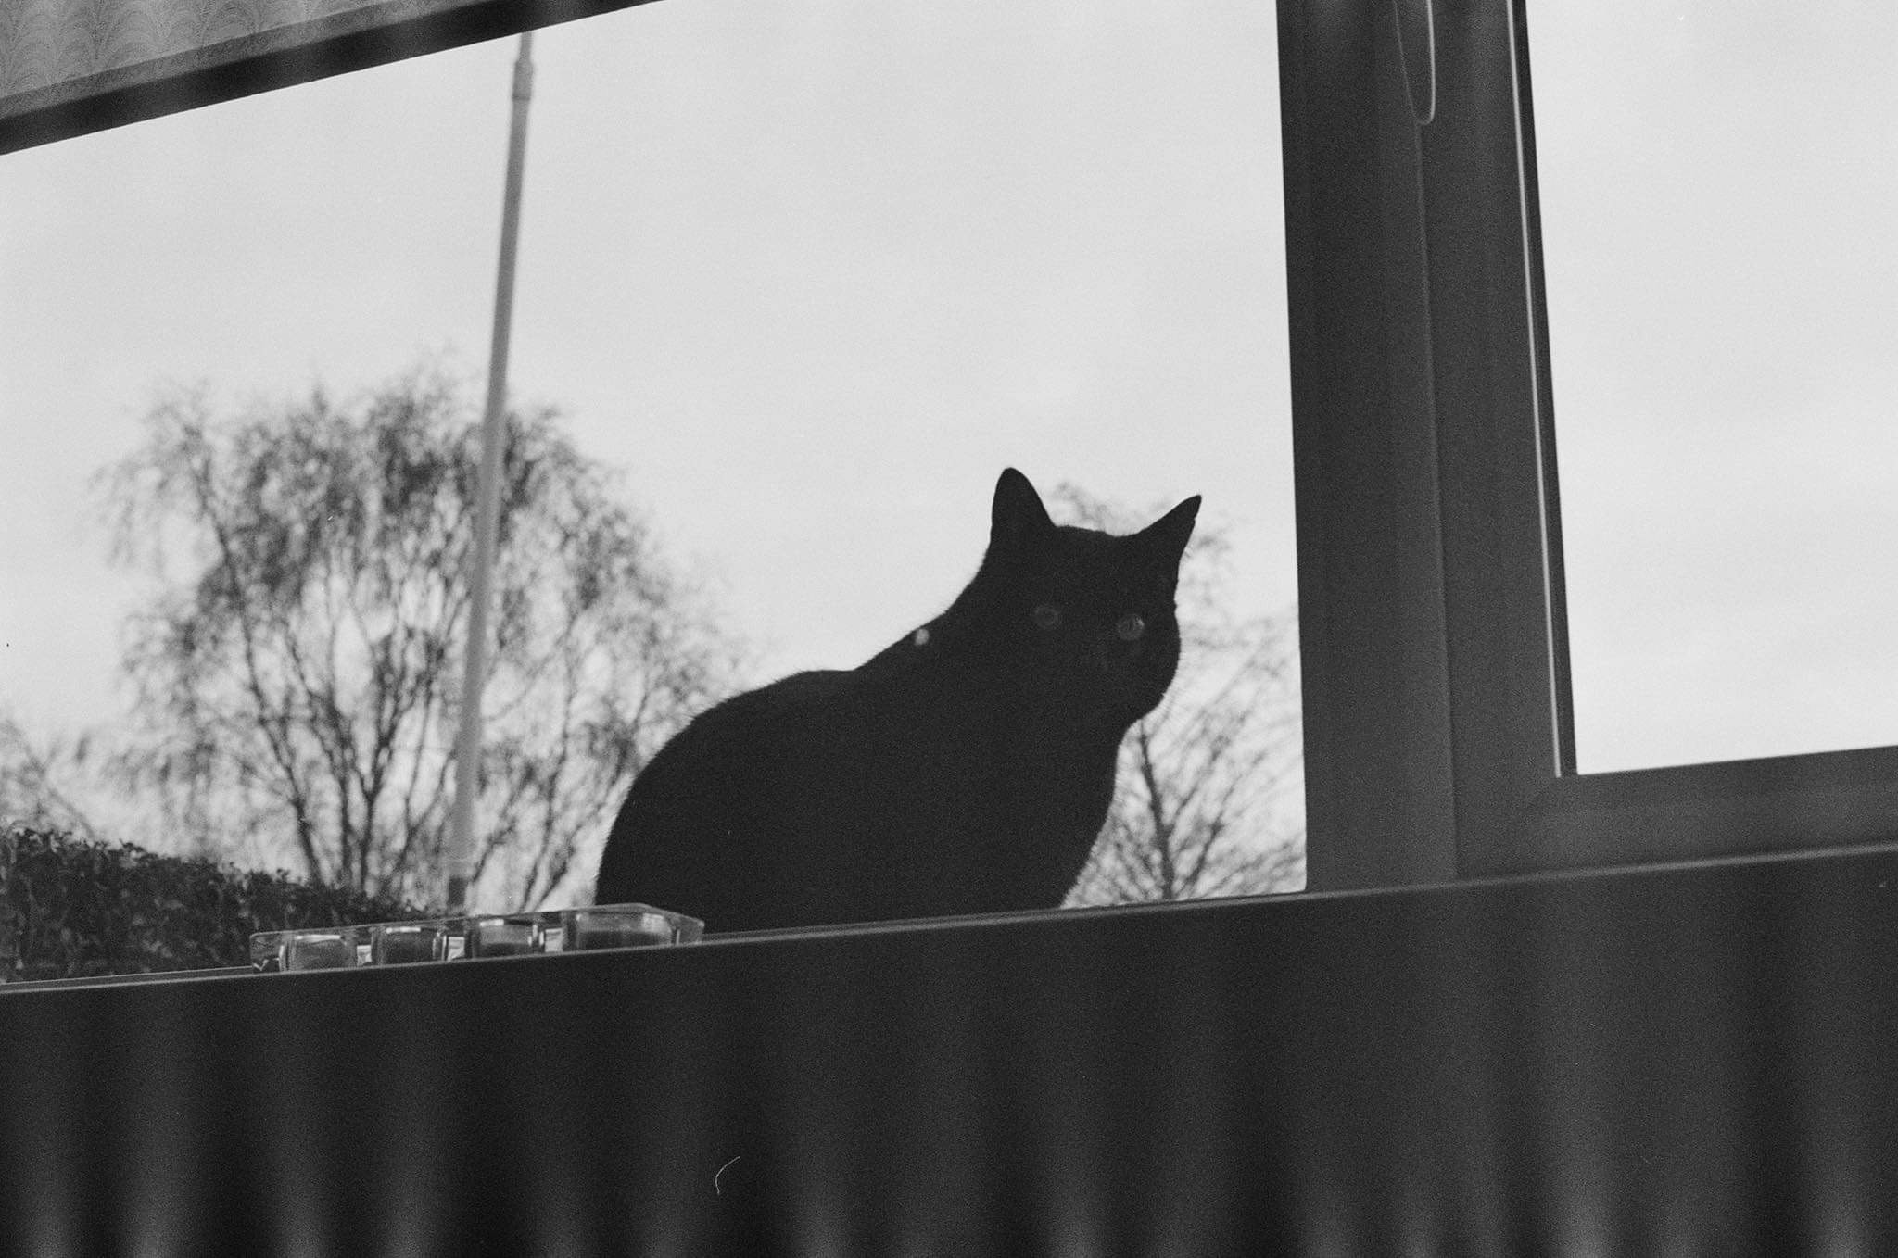

-Alan O’Connor.

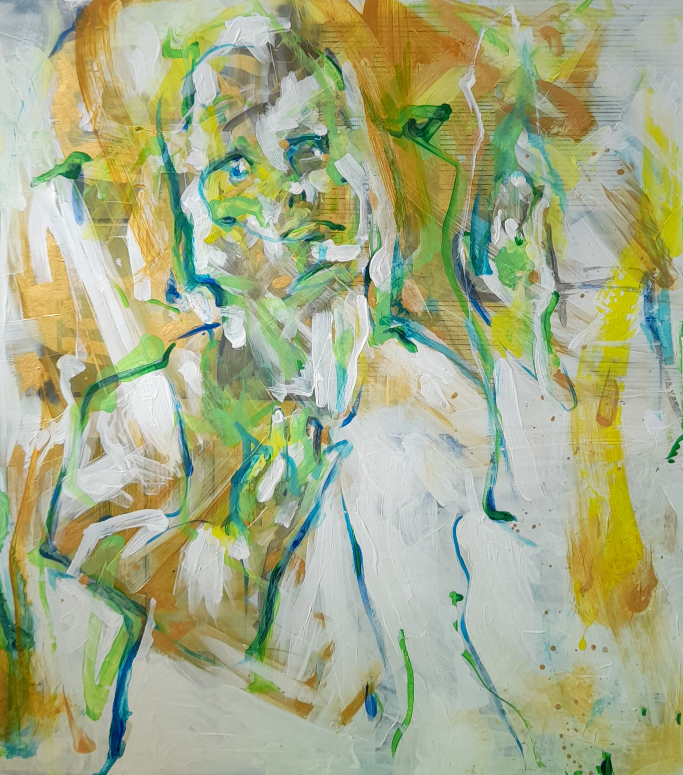
Flesh

-Summerisle Wilson.
Poppies

Don’t ask me your questions. I haven’t the answers.
All I can tell you are things that I know:
The sun rises eastward like three hundred foxes,
igniting the meadows in blazes of gold;
The moon spilling westward with light pale as pigeons

fills midnight fields with flocks of white wings.
Don’t ask me your questions. I haven’t the answers.
Poppies were blooming, a storybook red,
like foxes on fire, igniting the meadows.
The dead coil together like seeds in their sleep.

Young girl mem’ries, like clover and dove-weed,
fill fields with flickering—flocks of white wings.
Young girls stitch hours with blindness, with muteness,
turning deaf ears to the singing bedsprings
while fathers are binding up punk-rot-split branches

in faltering orchards; the sap seeps like blood.
A farmhouse can fill up with mice and with crickets;
with mothers as lonely as cracked jars of jam.
Mothers can welcome stray men for their solace.
Fathers like gardeners can tend to the land,

by day plucking peaches, and bucketing figs,
stropping the whickering blade till it sings.
At night men are dogs who ravage the lambkins
in fields scorched by sin. Mad-rage frays the seams
when poppies are blooming a slaughterhouse red.

Wells can be cradles for newborns, like secrets;
a small body pale as some glistening seed.
While husbands are working on combines and tractors,
the mattresses sing on like cricketed wings,
sighing and soughing, a strange sort of sadness.

Men can be husbands whose hands are like hammers.
As infants are slipped into stone-throated wells,
mothers hide linen stained redder than beetroot.
Husbands abandon machines in late fields,
shining with godlight, roar home like a storm.

I can’t say what happened, when children were hiding,
when fathers came in from the field, hammer-fisted,
when bedclothes were rumpled, still telling the story,
and darklight showed mother her nightclothes all gory,
all I saw were the floorboards, the nightstand, the door.

Another man’s voice had been pitched, low and tender.
I can’t say what happened; we children were hiding.
Father was working the far fields of buckwheat and
Mother was washing her nightclothes all bloody.
Then father came in with a broken plow blade.

The house split with thunder, all snarling and howling.
All I saw were the floorboards. The nightstand. The door.
The farmhouse ignited like fields full of foxfire.
Don’t ask me these questions. I haven’t the answers.
All I saw were the floorboards. The nightstand. The door.
The poppies were blooming; a murderous red.

-Kim Welliver.

Pocketful of Rye

{Ergotism: {n)poisoning due to ingestion of fungi infected rye. Symptoms of mania, convulsions, hallucinations, sensation of crawling skin may be the source of accusations that spurred the Salem witch trials } {Mercy Lewis, one of the first accusers}

sparking stars pinwheel during the dampest years--
dank hulls sprout St. Anthony’s fire
— feed the body brown bread
{mercy}

pinpricks bedevil our limbs; everything’s bent
{mercy} skewed to whelp
the hangman’s knot.

salt-bitten millstones grind madness from rye--Mercy,
{mercy}, beyond plague's foul step
we are forsaken,
black dogs and horned beasts
haunt the firelight, ravencroak
warps to words, {mercy, mercy} bleeds
into our small animal heat,

forsaken, {mercy} falsehoods, cauldron-swept, crawl
across our thresholds.
fear bloats into unmarked graves

goodwives, we struggle to breathe pondwater
in a year of red harvest

-Kim Welliver.

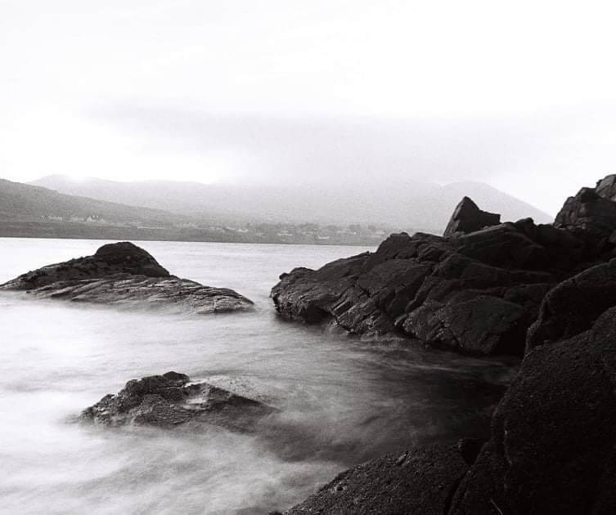
Selkie’s Call

-Brian Keenan.
Man waiting for a train

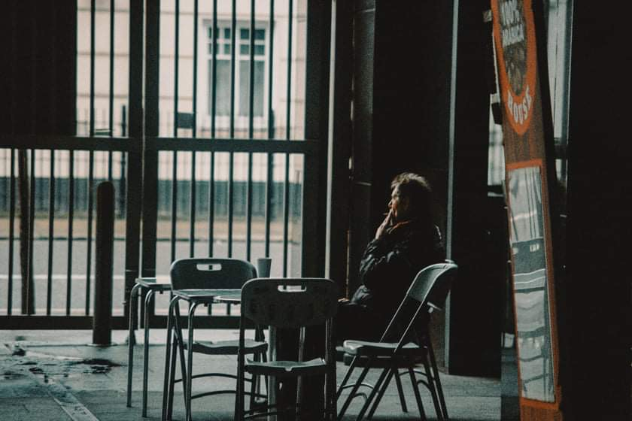

-Brian Keenan.

Hecate’s Night

Night pools like an ink spill.
The moon a sharpened blade,
an all-seeing eye. Fear ferments
like rot, layer upon layer.

The air is changed, some presence
rustles in the dead leaves, waits
to make itself known. Silence
like a shroud thrown over day.

Something is strangled.
Exhales its last breath. Hope?
Stars are goosebumps in the sky,
too far away to care.

Is this what it is to be haunted?
Things lost rattle, return,
their gnashing teeth
an eternal mourning.

And she watches it all, laughs.
Knows the strangeness of darkness,
the richness of its depths, the bones
it seeks to illuminate.

-Siobhán Mc Laughlin.

Iris

You were wearing pyjamas – that was the first thing I noticed. A pair of flimsy satin slippers on your feet soaked through with sludgy snow. Your hands were chafed and numbed to whiteness. You were pushing an empty swing.
When a child approached you hissed and shooed it away.
‘Mama, Mama, there’s a witch over there.’
I approached you, slowly, tentatively. Placed a gentle hand on your arm. You kept on pushing the empty swing.
‘Her name is Iris,’ you said. ‘She’s seven today.’
I tightened my grip and tugged at your arm.
‘Come on, love, it’s time to go home.’

-Rebecca D’arcy.

Even the Leaves

Rain beat steadily against the car as it drove south. Water ran off the road, but there wasn’t a danger of sliding. The country was used to hard rain, and the road had become gritty with the washed up dirt and gravel. The sunrise was only minutes away, and only the darkest blue on the horizon signalled the breaking of the night. Inside the car was warm, and the woman tapped the steering wheel with long nails, tap tap tap. A book lay face down in the front seat, spine wrinkled in the tradition of the well loved book. Ghosts and How We Understand Them by Regina S. Levine. As if we could ever really understand ghosts.
A ghost is not something to be feared. It is something to be respected, admired, perhaps pitied, but not feared. Ghosts live in the woods, in the ruins, on the skylines of cities, in between the wheels of the car driving south, squashed between one breath and the next.
They do not lurk, nor attack, nor scare misbehaving teenagers at a summer camp. They drift, wander, weep, cling to the earth for some great reason that they no longer remember. Regina got that much correct, and the woman kept driving south to the lake.
When she pulled into the parking lot, the rain had slowed to a noncommittal trickle. She pulled on her raincoat anyway but left the book in the car. The park was empty; picnic tables stood damp and forlorn without children and families and dogs and babies and young couples and old couples to sit and eat with them.
The woman walked toward the lake, following a well-worn path. Grass clung to her ankles at the edges of the path and soaked her socks, and she pushed her hands into her pockets. The lake was rippling with the last few raindrops. The morning was still dark and lightening on the edges, spilling into the sky slowly. She stopped at the lake’s edge and paused.
Nothing moved. The water’s surface had gone completely calm. The grass didn’t pull back from her ankles and the tree leaves didn’t bend under streams of water. Even the leaves refused to fall.
Nothing spoke. Not the birds, usually so excited to herald a new day. Not the drip of rain, the rustle of branches, the whisper of bush-bound mice. The silence lay eerily against the park and the woman held her breath.
When she turned, there was a figure sitting on the closest table. Head bent, entirely still. Long hair covered her face and the air around her seemed to refuse to move.
The woman breathed out deeply, took her hands out of her pockets, and approached the figure. She stopped a few feet from the table, posture relaxed, grass unmoving at her ankles. Light bled at the edges of the sky and the woman could see the figures balled hands in her lap.
“It’s ok. You can leave.”
Nothing can last forever. Not the living, not the dead, not even the things that bind us to the earth.
“He’s gone. He’ll never hurt you or me ever again. I made sure of it.”
A long sigh, like the first real breath after walking out of a dark room. It was quick, just one moment to the next and then the last of her sister was gone and the park cried out in relief. Leaves fell again in damp piles, the lake sloshed against its shores, and a mouse ran under the table like quicksilver. In between moments, there and gone.
The woman stood there for some time, and it wasn’t until the sun had peeked its eyes over the horizon that she walked back to her car, closed the book, and started driving north.

-Emma McCoy.

Postpartum
Changelings- a folklore tale of fairies stealing your true child and replacing them with a cursed soul.

All is yellow in nursery
Canary bird stickers call from one wall to the next.
The cot was gray once, you wrinkled your nose and painted it mustard with a brush so old it ended patchy and spotted.
We love it.

Her blankets are carefully made, methodically.
The sheets are pulled so tight her arms must be trapped; she can’t wave chubby fists at the rotating mobile.
You spent weeks, months carving tiny stars, cursing at splinters and filling the swear jar. You took me to dinner at the Italian place I like, 3 streets down.

The teddy Mum gave her in the hospital is tucked in beside her. You’ve sterilised it so often already he’s losing his brown fur’s shine.
The red ribbon round its neck reflects off black button eyes, a dull hungry gleam.
His stitched mouth is warped, rigid.

The room is too hot and you, you are too still.
You stand by the curtains, hair unbrushed for days and hanging in wild, wilting curls.
You’re dressed all in black, mourning clothes, humming a lullaby unwittingly, wringing hands clutch at each other’s frantic heat.

But I, I am cold. Freezing. Ice has trickled from the crown of my skull to the soles of my feet as I stand here.
She is not fussing or full or funny now.
Her head has slouched unnaturally, and my breath is catching and stopped.

That’s not her, she is wrong, you’ve said, notebooks full of folklore. That old fairy tale, the changelings.
You’re not well. You haven’t been for months. I’ve kept you safe. You’ve wanted tomato soup and cheese-toast and to keep far away from her. I’ve fed her bottles of baby formula while she screamed and screamed for you.
I’ve taken your phone to stop you calling the maternity ward. There was no swap, I tried to shake it into your shoulders, desperate and demanding and dangerous.
The doctors will take you if you don’t stop.

But now, she is wrong.
You wrench, nails bloody and breaking, at cracking mirrors.
Her tiny pink hat has slipped from elf-point ears.
Her soul must have fled that way when tiny bones snapped.
But no child is waiting, no portal summoned.
She can’t come back through that glass.

-Úna Nolan.

